**Basic PLC Ladder Programming Examples**

1. Switching on/off the Lamp whether they are at the bottom or the top of the staircase.

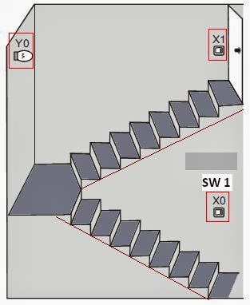

**Number of PLC Inputs Required**

X0 – Switch at the bottom of the Staircase

i.e. X0 turns ON when the bottom switch is turned to the right.

X1 – Switch at the top of the Staircase

i.e. X1 turns ON when the top switch is turned to the right.

**Number of PLC Outputs Required**

Y0 – Lamp

### PLC Ladder Programming:

|  |
| --- |
|  |
| PLC Ladder Programming Practice Problem 2 (**plc ladder diagram**) |

### PLC Ladder Program Description:

## plc ladder logic practice problems[.](https://www.startupjobsportal.com/)

* If the states of the bottom switch and the top switch are the same, both  
  ON or OFF, the light will be ON. If different, one is ON and the other is OFF,  
  the light will be OFF
* When the light is OFF, users can turn on the light by changing the state  
  of either top switch at the bottom switch of the stairs. Likewise, when the  
  light is ON, users can turn off the light by changing the state of one of the  
  two switches[.](https://listoftop.org/)

1. **Controlling the running state of the 1 ph motor by pressing START and STOP pushbuttons i.e. motor should remain in an ON state after the START pushbutton is pressed and should be OFF when the STOP pushbutton is pressed. Checking if the Motor is running normally by pressing the TEST pushbutton.**

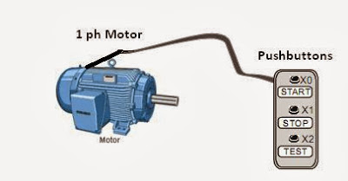

Topics Covered in this example is the **Latching Contacts Ladder Program.**

## **Number of PLC Inputs Required**

X0 – START pushbutton to Start the Motor

X1 – STOP pushbutton to Stop the Motor

X2 – Error signal from Motor to PLC.

**Number of PLC Outputs Required**

Y0 –1 Phase Motor

**PLC Ladder Programming:**

|  |
| --- |
|  |
| PLC Ladder Programming Practice Problem3 (plc ladder diagram) |

## **PLC Ladder Program Description:**

1. Press the START button lightly and X0 = ON. The Motor will keep running if  
   no error occurred (X3 = OFF). The action can be practiced by a latching circuit  
   which takes output Y0 as one of the input conditions to keep the motor running  
   even if the START button is not pressed(**See  
   normally open contact Y0 below X0**).
2. When the STOP button is pressed, X1 = ON and Y0 = OFF. The motor will stop  
   running.
3. If an error occurs (X3 = ON), Y1 will be OFF and the motor will stop[,.](https://www.startupjobsportal.com/)  
   running.
4. When TEST is pressed (X2 = ON), Y0 = ON. The motor will start running if  
   no error occurred (X3 = OFF). On the contrary, when TEST is released, the motor  
   will stop running. The testing function is performed by this process.
5. **Providing lubricant for the gearbox before the lathe spindle starts to run which aims to ensure that the oil pump motor starts first and the main motor starts subsequently.**

|  |
| --- |
|  |
| PLC Ladder Programming Practice Problem4 (plc ladder diagram) |

## **Number of PLC Inputs Required**

X0 – START pushbutton to Start Oil Pump Motor

X1 – START pushbutton to Stop Main Motor

X2 – STOP pushbutton to Stop Oil Pump Motor

X3 – STOP pushbutton to Stop Main Motor

## **Number of PLC Outputs Required**

Y0 – Oil Pump Motor

Y1 – Main Motor

### **PLC Ladder Programming:**

|  |
| --- |
|  |
| PLC Ladder Programming Practice Problem 4  plc ladder diagram |
|  |

## **PLC Ladder Programming Description:**

* This program is a typical application of the conditional control  
  circuit. Y0 = ON when the Oil Pump START button is pressed. Therefore, the oil pump  
  will start to provide lube for the gearbox of the main motor(Y1)
* Under the precondition of the operating state of the Oil pump, the main  
  motor (Y1) will be ON when the Main motor START button is pressed.
* During the operation of the main motor (Y1), the oil pump (Y0) needs to provide  
  lube continuously.
* The oil pump will be stopped when the Oil pump STOP button X2 is activated, and  
  the main motor will be stopped when the Main motor STOP button X3 is  
  activated.

1. The production line may be powered off accidentally or turned off for a noon break. The program is to control the counter to retain the counted number and resume counting after the power is turned ON again. When the daily production reaches 500, the target completed indicator will be ON to remind the operator for keeping a record. Press the Clear button to clear the history records. The counter will start counting from 0 again.

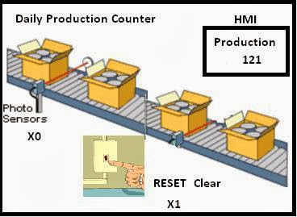

Number of PLC Inputs Required

X0 – Product Detecting Sensor.

X1 – Production Counter RESET/Clear

Number of PLC Outputs Required

Y0 – Production Counter Target Completed.

Number of PLC Counter Required

C120 – 16 Bit Latched Counter. (Max Count =32,768)

### PLC Ladder Programming:

|  |
| --- |
| [PLC Ladder Programming Practice Problem 5](https://www.plctutorialpoint.com/wp-content/uploads/2013/12/LadderProg5.jpg)PLC Ladder Programming Practice Problem 5 |
| PLC Ladder Programming Practice Problem 5 |

**PLC Ladder Programming Description:**

·       The latching counter is demanded the situation of retaining data when power-off.

·       When a product is completed, C120 will count for one time. When the number reaches 500, the target completed indicator Y0 will be ON.

·        For different series of PLCs, the setup range of the 16-bit latching counter is different.

1. Enabling the indicator to be ON immediately when the switch is pressed and OFF after a 5-sec delay by the switch.

**Number of PLC Inputs Required**

X1 – Start Switch.

**Number of PLC Outputs Required**

Y1 – Output Indicator

**Number of PLC Timer Required**

T0 – 5 second Timer, 100 ms Time Base. (See K50 Preset Value for Timer)

### PLC Ladder Programming:

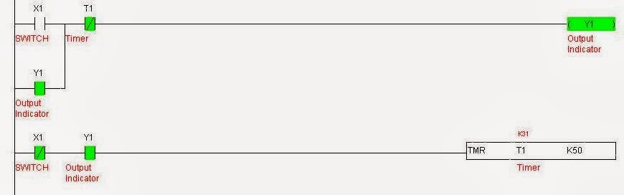

**PLC Ladder Program Description:**

·       When X1 = ON, TMR instruction will be executed. Timer T1 will be ON and start counting for 3 sec. When T1 reaches its set value, the NO (Normally Open)  
contact T1 will be activated and indicator YI will be ON.

·       When X1 = OFF, TMR instruction will not be executed. Timer T1 will be OFF and so will NO contact T1. Therefore, the indicator Y1 will be OFF.

1. **Enabling the indicator to be ON after a 3-sec delay when the switch is pressed and OFF immediately by the switch**

[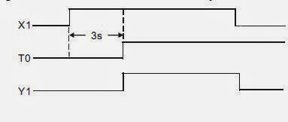](https://www.plctutorialpoint.com/wp-content/uploads/2013/12/Ladder7.jpg)

PLC Ladder Programming Training Examples

 Topics Covered in this example is **PLC Timer (ON Delay).**

**Number of PLC Inputs Required**

X1 – Start Switch.

**Number of PLC Outputs Required**

Y1 – Output Indicator

**Number of PLC Timers Required**

T0 – 3-second Timer, 100 ms Time Base. (See K30 Preset Value for Timer)

### PLC Ladder Programming:

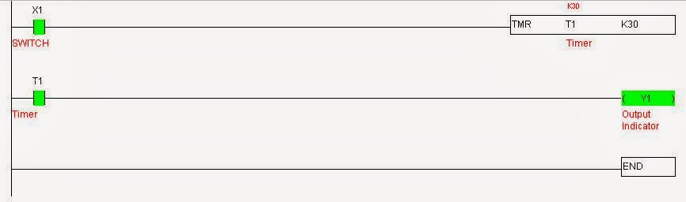

**PLC Ladder Program Description:**

·       When X1 = ON, TMR instruction will be executed. Timer T1 will be ON and start counting for 3 sec. When T1 reaches its set value, the NO (Normally Open)  
contact T1 will be activated and indicator YI will be ON.

·       When X1 = OFF, TMR instruction will not be executed. Timer T1 will be OFF and so will NO contact T1. Therefore, the indicator Y1 will be OFF.